1. Create one jenkins job using the below code and create three stages.  
   stage1: Git clone to download the source code

stage2: Sonarqube Integration to check the quality  
stage3: Slack Integration to send the alerts to slack

1. 1) Create one jenkins job using the below code and create three stages.

stage1: Git clone to download the source code  
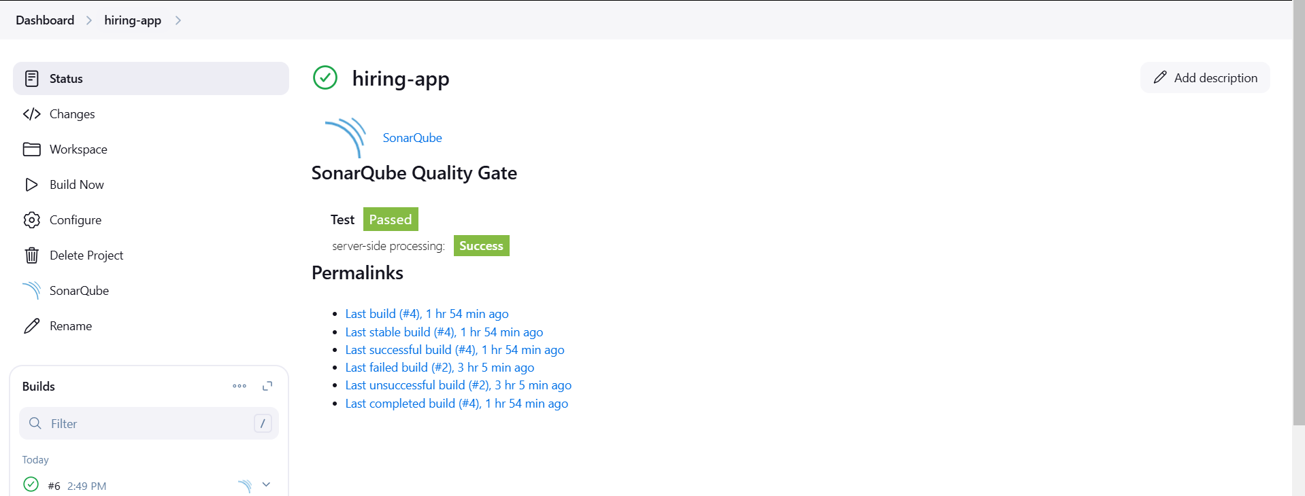

stage2: Sonarqube Integration to check the quality of code  
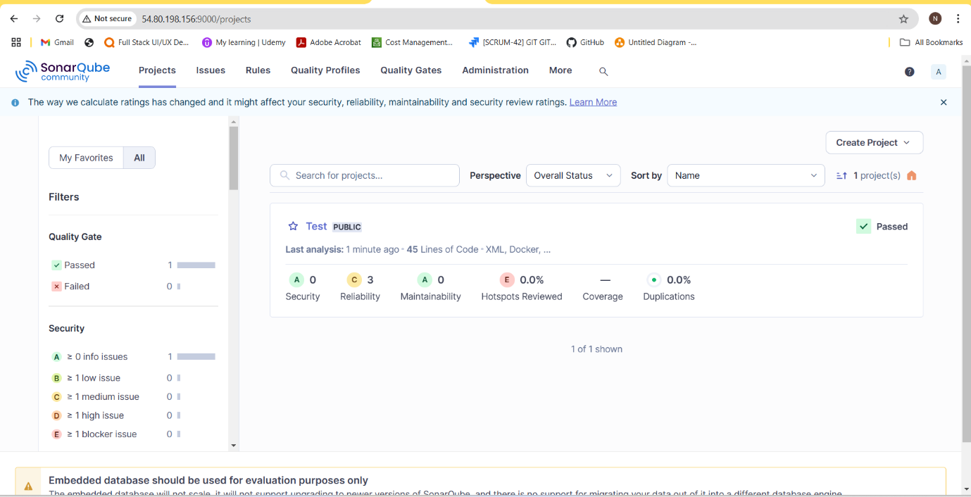

stage3: Slack Integration to send the alerts to slack  
